Carsten Büche  IT-Consultant  QM/Softwaretestautomatisierung  mit Winrunner von Mercury Interactive  und dem Framework von EMOS  für Keyword und Datadriven Tests.  Gründer und Leiter des  Forums von Yahoo für EMOS FRAME  Friedenstrasse 6d  85586 Poing  Tel: +49 (0) 8121 78661  Mobil: +49 (0) 160 94852947  Email: cbueche@cbueche.de  Homepage: http://www.cbueche.de/  Gulp: http://gulp.de/Profil/cbueche.html | 

EMOS Framework: Functional Testing Based on GUI-Modelling

Dean Rajovic

EMOS Computer Consulting GmbH
Oskar-Messter-Str. 25
85737 Ismaning by Munich
Germany

© 2001 EMOS Computer Consulting GmbH

ABSTRACT

In this paper we discuss the role of GUI-modelling in the area of functional testing and present a framework for the development and execution of automated functional tests based on such modelling. The main issues addressed by the framework are: rapid test development, intensive involvement of non-technical personnel in test automation and maintainability of the test environment that scales well for large systems.

The main features of our approach to GUI-modelling are reducing GUI operations to their SET (enter) and CHK (verify) alternatives and capturing the navigation as an intrinsic part of the test description. Through a simple linkage concept, an extremely high level of reusability of test data and test code is achieved.

The technical implementation is realised with the popular test tool WinRunner® from Mercury Interactive and is available under the Lesser General Public Licence (LGPL). The concept is applicable to practically any application designed for intensive data maintenance via "standard" GUI objects. It has been successfully applied to several highly complex test automation endeavours in branches like insurance, banking and telecommunications.

KEYWORDS: testing, test automation, functional testing, test framework, WinRunner

INTRODUCTION
There are many challenges in testing complex systems. Automating tests in such environments reduces some of them but introduces additional ones. Tests which are suitable for manual testing are not necessarily suitable for test automation (provided they have been specified/written at all). The sheer amount of possible test cases can scare even the most experienced test manager/specialist. Especially when such tests are to be carried out with hopelessly understaffed test teams and within ridiculous time frames...[5] Organising numerous test artefacts into a maintainable complex that survives long enough to prove its usefulness is a very challenging task [3, 4, 6, 7, 8].

The most common approach to functional testing is by exercising the application through its user interface. Automation of functional tests simply cannot ignore the GUI-oriented test tools from vendors such as Mercury Interactive, Rational, Segue, Compuware, etc. Although these tools are capable of implementing very complex approaches, advanced users seem to be left alone to discover the advanced techniques on their own.

It does not take much browsing through the literature or in the Internet to discover that many people found their own solutions [1, 2, 3, 8]. These solutions always seem to follow the same path: from capture/replay (record/playback) via scripting and data-driven testing to test frameworks. Due to the lack of firm theoretic fundaments that could guarantee their universal applicability (which is probably the reason none of the leading tool vendors offer such frameworks), these frameworks pair their own testing methodology with the technical support for it. Nevertheless, they all try to solve the same problem: make the test automation more effective and more efficient.

When it comes to testing via the application's user interface, these frameworks appear to use the same approach: each models the test design in its own way and provides an interface to one (or more) standard GUI-centred test tool that executes the tests. The most influential test framework so far is probably the CMG's TestFrame® [1]. This is the powerful framework based on a keyword-driven separation (in their terminology: "action words") between the test data ("test clusters") and the test scripts. The most important common property of almost all of the approaches at this maturity level is the separation of the test data from the test scripts. The more advanced the separation, the more advanced the concept (e.g. simple data-driven versus keyword-driven approach).

THE “BUSINESS CASE SYNDROME”
Advanced concepts attempt to express the test cases in terms of business processes: the high-level abstractions that hide their actual implementation as much as possible. The promised benefits of such "business modelling" include the independence of the particular user interface, increased comprehension to non-programmers and improved requirements/design coverage.

However the separation of scripts and data has its costs. The closer we get to the "business language", the bigger the gap to the actual test implementation. Under the premise that we attempt to ignore the particular user interface, it becomes increasingly more difficult to find reusable code patterns that relate to such "business language". Such patterns however are fundamental to bridging the gap between business models and their implementation.

Business processes are rarely simple. The problem is often "solved" by chunking big transactions into smaller parts and/or by reducing the information that has actually been tested. We often see functions like enter_xxx(...), delete_xxx(...) and modify_xxx(...) accompanied with the claim they test the given business processes. The questions is whether they really do.

The test code must be flexible. Among other things it should be able to enter and check valid situations, provoke errors, take alternative, unusual or illegal paths through the application, handle dynamic (context-sensitive) parts of the application and check the reaction of the application at many different places. The purpose of this code is testing. It should serve as a "playground" for implementing test ideas. It should be able to mirror the behaviour of the real human (and destructive) tester as much as possible. This cannot be achieved with a code in which many decisions are hard coded. When an alternative "route" is needed or when things get changed (as they inevitably do with testing) one must make adaptations somewhere to get the code working. Questions that arise are:

- Where to adapt?
- Who can adapt it?
- How much does it cost (time/money) to adapt?

A test automation expert (test programmer, tool specialist) is permanently forced to make decisions about what information to make public (i.e. make it a "business case") and what information to "bury" into the test scripts. The trade off is that the information which is made public can (usually) be changed by non-programmers (domain experts, end users, testers) whereas the "buried" information requires programming expertise to change. Simple changes in the application's user interface can easily affect plenty (hundreds) of test cases if the information is exposed or only a few lines of code if the information is hidden. Obviously, a careful balance must be found. However, it is a gamble! More often than we would like, changes affect both exposed or hidden information regardless of our "clever" balancing. Those who know the tricks of test automation will appear to be "luckier" than the others.

The main benefit of test frameworks is in providing guidelines for those who use them (test designers, test programmers, end users, system designers, etc.). A good test framework provides good answers to many difficult questions. The area that still requires plenty of research is in finding an effective way of expressing (or even generating) test cases that are sufficiently legible for humans as well as machines.

GUI HAS IT ALL
In our approach, we consciously digress from the commonly accepted practice of expressing test cases in a way which is "independent" of the particular user interface. To the contrary, we concentrate on the application's interface for the following reasons:

- it is the aspect that none of the functional test automation approaches can ignore,
- it is the only common platform for discussions suitable to all parties,
- it is the primary area of interest to most expert users and test managers, and
- it is indeed suitable for expressing (functional) test cases.

Our experience has shown that by modelling the user interface we are able to express the "business cases" while preserving most of the other benefits of "business modelling" (separation of tests and scripts, increased comprehension to non-programmers, maintainability, scalability) and provide for the extremely rapid and robust test automation. The approach is particularly well-suited for applications with complex user interface focused on data maintenance. This covers a very broad range of business applications in practically all branches.

The basic objectives of our approach are:

- it must be set up quickly,
- it must rapidly evolve (new test cases must be adopted quickly),
- it must eventually scale to accommodate huge systems,
- it must be able to "live" long (maintainable over many product cycles), and
- it must be useful (test what was intended to be tested).

Our GUI-modelling idea is based on a pretty heretical hypothesis. If there is an edit field on the application's GUI, all that a functional test will do with it is to enter, retrieve/check or ignore its content. (One may argue that the field attributes (label, position, enabled/disabled, etc.) also need to be checked. This may be true. However, compared to the operations on the field's content, the operations on field's attributes are rare. For this reason, we concentrate on the content. Nevertheless, we do know how to handle both.)
The same holds true for most of the other GUI object types. For example, a push button will be pressed or ignored, a check box will be set or checked whether it is set, elements of list boxes will be selected or checked for their presence, etc. In other words, for every GUI object type there are only a few operations that need to be applied in order to perform most of the functional testing.

The first most important concept of EMOS framework is that the GUI of an application is exercised with operations in either SET-mode (enter the data in an edit field, select an item in a list box, press the button, etc.) or CHK-mode (check the content of an edit field, check the state of a radio/check button, check the existence of a list item). For this purpose our framework contains libraries of "standard wrappers" for the most commonly used object types (edit fields, static text, list boxes, all sorts of buttons, menus, toolbars, etc.). These wrappers are functions that automatically:

- determine the mode to be used,
- retrieve the test data which is to be used for the operation,
- call the appropriate native function, and
- provide the standard reporting in the test result log.

The second most important concept (they are both so important that we don't know what else to call them but "most important") is the modelling of the navigation through the application's GUI outside the test scripts. We highly discourage (apart from very few exceptions) hard-coding of any sort of information related to the user interface into the test scripts. The decisions which are all part of the test description include:

- what tab in a tab dialog to select,
- what menu item to choose,
- what entry in a tree to select,
- what button to press,
- what keyboard combinations to type.

We take into account that simple changes in the user interface might require complex changes in the test description (complex changes always require complex adaptations regardless of the concept).

The benefit of this approach is that (most of) the test scripts that need to be created need only concentrate on exercising the application's GUI. They do not (!) implement any particular test procedure (case) of any form. The instructions of what to test (what to enter, what to check, what to ignore, where to navigate to, where to come from) come from the test descriptions that reside outside the test scripts.

Why is this beneficial? First, one can start implementing the test scripts without knowing much about the concrete test cases that need to be implemented. Although we are not very proud of it but we have seen so much poor test planning and bad test organisation that we consider this to be the "normal" situation. We do try our best to influence the test practices toward something we consider better. However, if you want to survive in the jungle, you'd better get used to the trees, rain, animals, ...

Second, one can generate most of the test scripts, test data templates and the abstractions of the GUI objects. We do not yet have the statistics over the existing applications of EMOS framework but we estimate that some 60-90% of the test code can be generated simply by pointing and clicking at the application's GUI.

When we talk about the rapid test development it is these two benefits we have in mind. One can start automating as soon as there is something testable around and even then one is actually "only" clicking her/his way through. Well, it is not as simple as it may sound but it is quick.

THE ARCHITECTURE
There is not much difference between EMOS framework and TestFrame or similar approaches in that the test data is physically separated from the scripts. EMOS framework uses Excel® spreadsheets to store the test data. The most obvious benefit of such an approach is the high level of acceptance by non-technical personnel (test automation is difficult enough, learning yet another over-complicated tool can quickly scare even the most advanced users). Another benefit is the powerful calculation capability within the test data which greatly increases the expression power of the test cases.

The test data is "connected" with the test scripts via the keyword concept very similar to the TestFrame's "action words". Unique names are used to identify the function which is designed to process the test data associated with the keyword. In our terminology they are called test blocks.

A typical test block contains a sequence of test primitives or atomic test units. If the test primitive corresponds to a particular GUI object, we refer to it as a physical test primitive. Otherwise it is an abstract test primitive which represents a deliberate piece of information that is made available to test scripts for any purpose. A particular test block may contain any combination of test primitives. During test execution each test block runs either in SET or CHK mode. (There are other modes available. For simplicity reasons they are not discussed in this paper. For example GEN mode generates a new test case or updates an existing test case with the information currently displayed by the application.) For physical test primitives this means that they use or verify the application respectively. Abstract test primitives deliberately interpret the test block mode.

Test blocks are grouped in Excel spreadsheets or data tables. Each data table may contain many test cases. Test cases are usually organised in columns. The column-oriented format is most suitable for expressing test cases for complex GUIs that involve numerous user interface objects and complex navigation. The number of test cases is therefore limited by the number of columns (256). The number of test primitives (i.e. GUI objects involved in test) is limited by the number of rows (64k). It is however possible to organise test cases in a row-oriented structure. This is the preferred representation for simple data-driven tests (involving weakly structured test data). In this case the number of test cases is limited by the number of rows (64k) and the number of test primitives by the number of columns (256). Both representations can be freely combined since a column-oriented test case can "call" a particular or all of the row-oriented test cases and vice versa. The test automation specialist is responsible for choosing the representation that is most appropriate for the given situation. For the rest of this paper we will consider only the column-oriented test cases because they build the essence of EMOS Framework and are by far the most used ones. Each test case has the name allocated in the particular cell of the first row in the data table.

Each test case contains a single cell containing the test sequence which is a vector of test block names, links to other tests and/or a few other instructions. The test sequence defines the order in which test blocks are executed and is interpreted by the test script called the test driver. The test driver is the script that connects the data table with the test code. For each test block name the test driver calls the appropriate function or executes commands specified in the test sequence. Since test driver is the script that searches for the test sequence in a data table it can also search for anything else. We use this feature to implement the test reporting. In addition the test driver is the script responsible for loading everything else which is necessary to execute the test blocks. Our framework is tailored for WinRunner so test drivers typically load related GUI-maps and compiled modules (libraries).

Test cases are grouped into test suites. A test suite is yet another Excel table containing a sequence of test sets that need to be executed. Each test set is an instruction for executing specified test cases from the specified data table by the specified test driver. Therefore a test suite is an instruction to execute different test cases in different data tables by different test drivers. A particular test suite should, of course, group the test for a particular purpose: a complete regression suite, smoke test, sanity check, etc.

An alternative way of grouping test cases for a particular purpose is by means of test sets within TestDirector®, Mercury Interactive's test management tool.

EMOS framework is technically realised through a layered set of libraries (WinRunner terminology: compiled modules). It is packaged as WinRunner AddIn which is a plug-in component that dynamically extends the capabilities of the native product. Captured in an UML deployment diagram, the simplified architecture looks like this:

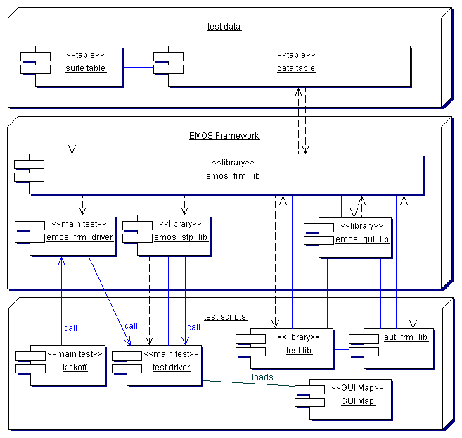
Figure 1: EMOS Framework Architecture

Due to the simple conceptual model the actual realisation tends to be very similar regardless of the system being tested (provided the naming conventions and design standards have been adhered to).

AN EXAMPLE
Let's see how we actually test with our framework. Please recall the two "most important" concepts we mentioned earlier and then consider the following (extremely simple) screen shots from a real-world application. Our goal is to create a few tests for the dialog for maintenance of user information (title: "Benutzer bearbeiten"). We would normally use our point-and-click wizard to generate the test code and the template for the test data. The basic modelling principles are:

- analyse the possible usage of the particular part of the application,
- identify the navigation part and decide how to model it (we probably have a pattern for it),
- select the objects of interest (test primitives),
- choose the appropriate operation for each object, and
- group the objects into some meaningful units (test blocks).

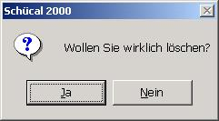
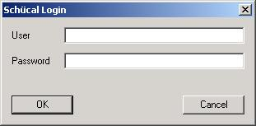
Figure 2: Example: Login and Message Dialogs
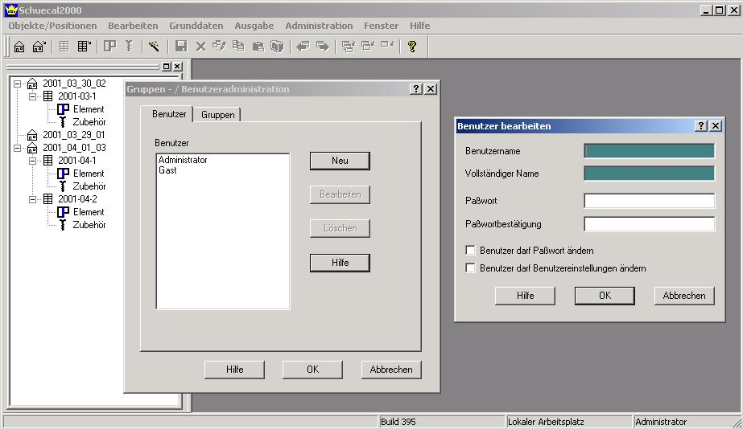Figure 3: Example: User Information Maintenance Dialogs
In this example we show a little bit of navigation and a little bit of data entry.

The navigation between dialogs is: log in, select menu Administration; Benuter / Gruppen, choose tab Benutzer (user) for user maintenance, choose the appropriate action Neu (new), Bearbeiten (edit) or Löschen (delete) (we ignore Hilfe / help in this example), close the dialogs either with OK or Abbrechen (cancel), handle the possible warning message dialog.

For the purpose of this example we are going to implement five test cases that would normally be the first candidates for test automation. We place them all in a single data table.

Test 1 checks the default values shown after selecting the action for new user.
- Notice the CHK mode and the keywords <<clear>> that specify an empty edit field.

Test 2 checks that password fields are echoed with stars (*).
- Notice the SET mode (default if nothing else specified).
- Notice the ignored test primitives (indicated by the cells with no content).
- Notice the "link" to column 2_1 (instruction LINK in the Testsequence cell of test 2) which was needed in order to re-apply the test block Benutzer_Details in CHK mode containing different data.
- Notice the handling of a pop-up message that appears when trying to cancel the dialog that has been modified.

Tests 3 to 5 define a new user, save, reopen and check the content and finally delete the user.

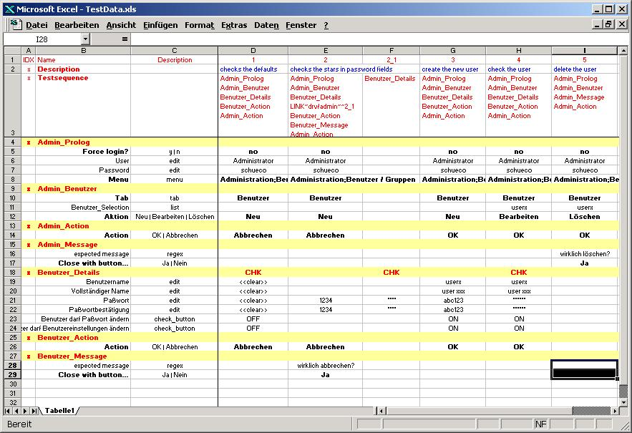
Figure 4: The Data Table

In order to run all the tests at once, we would either create a test suite table like the one shown in Figure 5 or an equivalent test set in TestDirector.

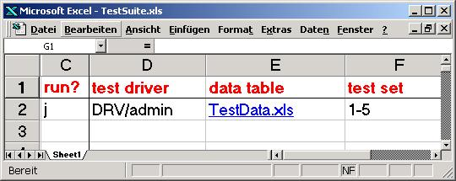
Figure 5: The Suite Table

Test suites themselves can also become huge for big systems. For the purpose of this example we are keeping things simple.

A FEW IMPORTANT DETAILS
A very interesting issue is the test block Admin_Prolog. Hidden behind this block is some of the most complicated code. It is this block that makes the test suite extremely robust: it invokes the application if it has not yet been started, it re-invokes it if the current user is different from the desired one and it either gently closes or kills (eventually via Task Manager) the application if it is not found in the desired state. There are other types of such stereotype test blocks. We apply them to solve particular types of problems as much as we can.

EMOS framework is built on a recursive concept. The key to flexibility and reusability of the test design is the concept of "test linking". By the simple syntactic construct one can extend the test sequence to another test case (and return back) either in the same or in some other data table. The basic test design practice is to create data tables "specialised" on a particular part of the user interface and populate them with the test cases. (In our example we have grouped all that was needed for user administration into a single data table.) Complex "business cases" are usually expressed in data tables that only contain links to the specialised data tables. Such business case tables are normally enriched with descriptions and references to test specifications in order to improve test reporting.

Notice how the navigation part (menu items, tab names, push buttons, etc.) is modelled. This is an extremely simple example. Modelling the navigation is the most difficult (i.e. creative) activity in GUI-based testing. The way it is modelled depends heavily on the support embedded within the framework and the modeller's experience. The great strength of EMOS framework are numerous patterns that resolve difficult GUI constructs in a uniform and elegant way.

An example of the code that implements the particular test block is shown in Figure 6.

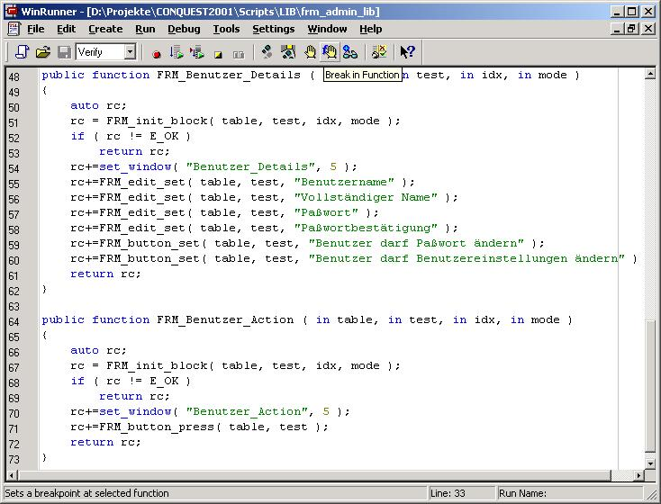
Figure 6: Examples of test block functions
The great portion of the test code looks like this. There are no loops, no decisions or other error-prone constructs (ignore the if-statement in the example, it is always there). These functions are usually 100% generated.

Operation wrappers such as FRM_edit_set(...) have been reused over and over again. They correspond to particular physical test primitives. The abstract test primitives usually do not have such elegant representation. They require that an individual (i.e. error-prone) piece of code be written for each one.

Notice how the complexity of the test code grows almost linearly with the complexity of the user interface. This is a very desirable property. Complexity of the test cases (i.e. data tables) usually grows at a much faster rate. In other words, a particular change in the user interface causes a proportional amount of change in the test scripts whereas corresponding changes in test data are more dramatic.

Nevertheless, we still advocate exposing the information that an ordinary user of the application can see (e.g. tab names, menu items, names of the push buttons, etc.) to the data tables. If this information changes, all affected test cases need to be changed. Usually, this is not so much trouble as it might seem at first glance. Typically, it is easier to find skilled testers that can maintain the data tables than skilled programmers that can maintain the test scripts. Our experience is that a single test programmer can educate and serve some 5-10 testers if data tables and test code are created according to EMOS framework principles.

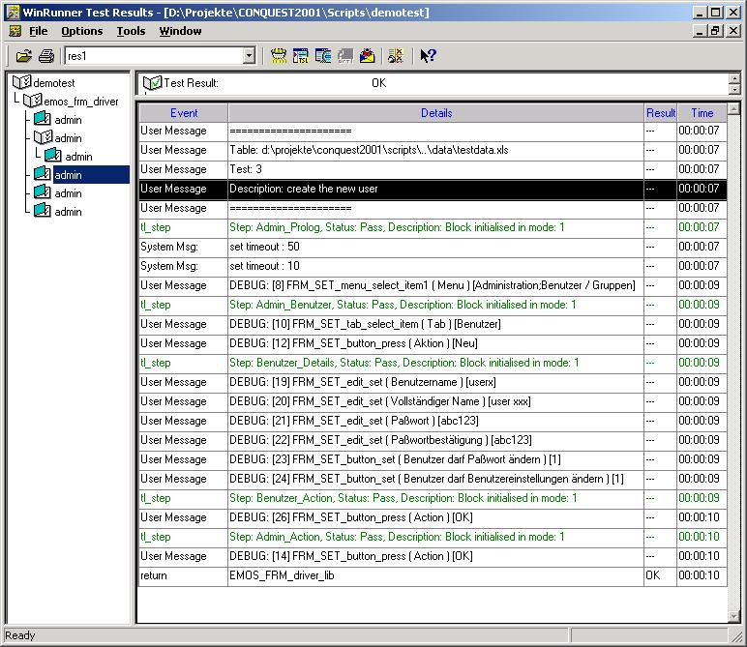
Figure 7: Excerpt from the corresponding test result
Finally, a few words about the test results. Due to the extensive usage of "operation wrappers", it is easy to adjust the reporting to particular needs.

A good test reporting should facilitate the analysis of test failures. In the ideal situation the cause of the failure should be determinable solely by analysing the test result (without the need for test re-execution).

EMOS framework reporting has been designed for such purposes and significantly improves the expression power of the reports generated by the underlying test tool.

CONCLUSION
EMOS framework does not solve all testing problems. It was never designed for that purpose. However, the problems it does solve are solved in a very elegant and efficient manner. The concept is non-intrusive and can be combined with practically any other scripting technique. It has been successfully applied to a variety of systems, some of them extremely complex. GUI-based client/server, Java, Web and even DOS applications have been tested using this approach. We are constantly surprised about its wide range of applicability.

EMOS framework was designed by test consultants. Facing unrealistic expectations, time pressure, variety of systems, platforms, design methods and bad test planing is nothing unusual in this job. Methodological test approaches are often inappropriate in such situations because there is simply not enough time, resources or acceptance to apply them. EMOS framework has been a great help even in some hopeless situations. The fact that scripts do not implement any particular test but only describe what could be done with the application is the key aspect. Once set up, the system can quickly accommodate a huge amount of tests provided the domain experts are appropriately involved and trained.

The understanding of the underlying concept influences the chances for the successful application of EMOS Framework more than anything else. It may come as a surprise but it is not the testers or the domain experts who seem to have difficulty in understanding the concept. It is the programmers! Apparently, it is not easy to teach people to write scripts that appear to test absolutely nothing. All these scripts do is specify how the GUI looks. Boring scripts without ifs and loops. What can they be good for?

The modelling freaks might be asking themselves "Wait a minute! They are talking about GUI modelling all the time. Where are these models?". They are these boring scripts! Testing is being performed somewhere else -- not in the scripts but in the data tables and in the framework. Data tables are those which specify the test. Framework executes them. The purpose of the test scripts, which lie between the test data and the framework, is to provide the "bricks" for playing the game. Indeed, we often compare testing with EMOS framework with playing LEGO®. Test blocks are the bricks. The test itself is whatever one does with them. The simpler the bricks, the easier the game. What the test programmer needs to do is to make all the bricks look similar so that they can be combined.

The generation of the test code is based on the capability of the underlying test tool to "see" the user interface. This is the foundation for the implemented "point-and-click" generation technique. With access to the source code of the tested system one could create parsers that generate most of the test code. This could drastically reduce the amount of clicking around that is otherwise necessary.

We mentioned that complexity of the test scripts closely relates to the complexity of the tested GUI. We believe that useful metrics can be developed particularly for the purpose of estimating the effort needed to develop the test code.

EMOS Framework seamlessly integrates with WinRunner and TestDirector. Combined with requirement management tools such as TBI's Caliber-RM and Caliber-RBT it is possible to create an extremely powerful platform for functional testing in which all phases of the test life cycle -- from the conception through automation up to defect tracking -- are backed by the appropriate tool.
REFERENCES

1. | Buwalda, Hans, Testing with Action Words  White paper Netherlands (1994)  http://www.testframe.com/
2. | Dustin, Elfriede, Rashka, Jeff and Paul, John, Automated Software Testing  Addison-Wesley Longman, Inc. (1999)
3. | Fewster, Mark and Graham, Dorothy, Software Test Automation  New York, Addison-Wesley, ACM Press (1999)
4. | Hayes, Linda G., The Automated Testing Handbook  Software Testing Institute, Texas (1995)
5. | Kaner, Cem, Negotiating Testing Resources: A Collaborative Approach  Paper presented at Quality Week 1996,  http://www.kaner.com/lawst1.htm
6. | Kaner, Cem, Improving the Maintainability of Automated Test Suites  Paper presented at Quality Week 1997,  http://www.kaner.com/lawst1.htm
7. | Kaner, Cem, Pitfalls and Strategies in Automated Testing  IEEE Computer, April, 1997, p. 114-116
8. | Zambelich, Keith, Totally Automated Data-Driven Testing  White paper 1998,  http://www.sqa-test.com/w_paper1.html

Dean Rajovic is an enthusiastic advocate of software quality with over fifteen years experience in software development and software testing. He has worked as a developer, system analyst, project manager and tester in a variety of international projects. He holds a B.Sc. in Computer Science and Organisation from University of Maribor, Slovenia and is an active instructor (CPI) for products of Mercury Interactive, Inc. He leads the department for Quality Management and Software Testing of EMOS Computer Consulting GmbH, Munich and can be reached at drajovic@emos.de.

I would like to thank Ms. Dorothy Graham for her proof-reading and inspiring comments, Brigitte Kahlau for her endurance and energy that made it all possible, Lynn Knight for very competent editing and the last-minute support and most of all to my wife for her endless support and understanding. Without your help this paper would not have been worth publishing.

